**Cyclistic Case Study**

Kevin Lim

May 27, 2023

**Business Task**

Cyclistic is a successful bike-share service with a fleet of 5,824 bicycles and 692 stations located in Chicago which can be taken out and returned to any station. Cyclistic’s original marketing strategy was appealing to broad consumer segments. One thing that helped was the flexibility of its pricing plans such as single ride passes, full day passes, and annual memberships. Customers who purchased a single ride or full day pass are considered casual riders, while customers who purchased memberships are considered as annual members. Cyclistic’s finance analysts concluded that annual members are more profitable than casual riders. So Cyclistic is attempting to shift marketing efforts to convert casual riders to annual members. The business task is to identify the differences between casual riders and how annual members differ.

**Data Source**

The data that has been used is the Cyclistic trip data from 2022. The trip data can be found [here](https://divvy-tripdata.s3.amazonaws.com/index.html). The data has been made available by Motivate International Inc. under this [license](https://ride.divvybikes.com/data-license-agreement). Note that Cyclistic is a fictional company.

**Data Cleaning/Manipulation**

The Excel files containing the trip data for each month were imported into SQL Server. The data was combined into one table using the UNION function. But there was an error with unionizing the tables together into one due to data type being mismatched. So, the January trip data was used to compare the differences in data types between each table and any columns that had mismatched data types were homogenized. The tables were then combined into one table called “tripdata_2022.”

The dataset was then checked for duplicates, and none were returned. By running a simple SELECT function, I noticed a few nulls in some of the columns, which were then replaced with “N/A” and “0.”

A column was then created to find the difference in time between started_at and ended_at. It was then converted into minutes in a new column for easier interpretation. Another column was created to get just the date from started_at called “date_rented,” as well as a column that got the weekday from the started_at column called “day_of_week.”

The time was also isolated from started_at and ended_at into new columns called “started_time” and “end_time.” Then a new column called start_time_of_day and end_time_of_day was created to split the time between morning, noon, evening, and night. Finally, a column was created to get the month from started_at called “m0nth”.

**Data Analysis**

The following visuals used for data analysis were created in Tableau. A dashboard has been created to display these visualizations which can be found [here](https://public.tableau.com/app/profile/kevin.lim8418/viz/CyclisticDashboard_16847710185140/Dashboard1).

**Table 1**

Table 1 shows the type of bike rented based on casual riders and Cyclistic Members. Based on the numbers that are shown, casuals seem to prefer the electric bike over the classic bike, with a significant difference of more than 300 thousand. Members on the other hand favor renting both types of bikes, but with a slight preference towards the classic bikes over the electric bike.

**Figure 1**

*Note: The top visual is the average time for casuals, while the bottom visual is the average for members.*

Figure 1 shows the differences in the average ride time of casual riders and Cyclistic members. Casuals seem to bike longer than members on average, with the least number of minutes biked being 24 minutes. I hypothesize that casuals bike more on average because they cannot bike as often as riders with a membership, so they want to get more value out of their rent. Members bike less than 15 minutes a week on average. Both casuals and members tend to bike more during the weekend, and less during the weekday.

**Figure 3**

*Note: The left chart represents casual riders, while the right chart represents Cyclistic Members.*

Figure 3 depicts the number of rides rented per week. Casual riders tend to rent bikes during the weekend, with Saturday being the most popular day for casuals to rent bikes. Casuals rent bikes less during the weekdays, unlike Cylclistic members. The Cyclistic members seem to be the inverse of casuals where they rent rides more during the weekday and rent the least during the weekend. The most popular day for members to rent bikes is during Thursday, followed by Wednesday and Tuesday.

**Figure 4**

Figure 4 displays the number of rides rented per month throughout the year of 2022. We can see that overall, members have rented out more rides per year than casuals. I assume this is the case because of the membership allowing them to rent rides whenever they want. But generally, members and casuals seem to start renting more rides starting in February and peaking around summer. Members peak at around 427,008 rides in August and 406,055 rides for casuals before they start declining as the season changes. It seems like the summer season is the most popular time for customers to ride a bike.

**Figure 5**

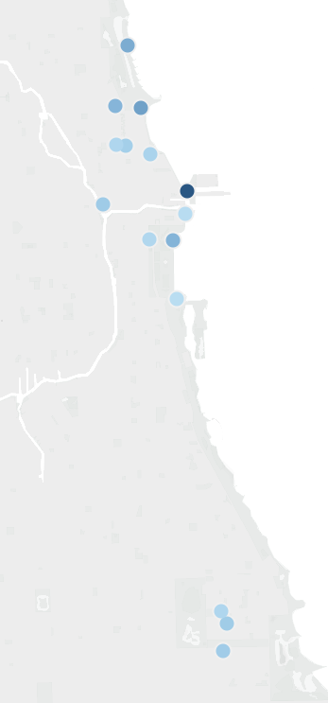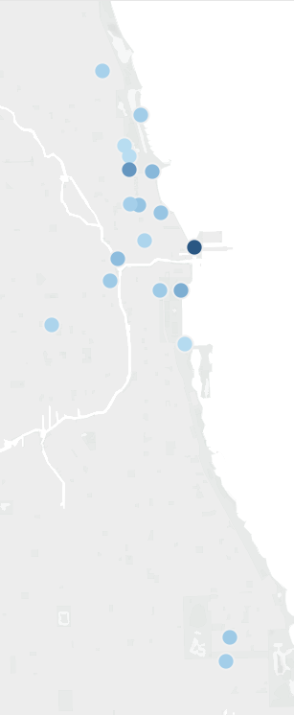

*Note: The light to dark colour indicates the least and most popular stations that were visited.*

Figure 5 depicts the most popular start and end stations for riders. The most popular stations in Chicago seem to be the stations along the coastline, based on the spread of stations in the depiction in Figure 5. One thing to note is that members seem to also prefer certain stations that are south of where the cluster of popular stations are.

**Table 2**

Table 2 shows what part of the day customers prefer to start and end their day at. The most popular part of the day to start and end is noon and evening. Casuals are more likely to start and end their rides during noon and evening based on the percentages above. Members seem to have a stronger preference to start and end their rides during the morning.

**Recommendations**

Based on the data analysis, here are a few recommendations to help convert casual riders to Cyclistic members:

* Offer a seasonal discount for spring/summer. This is the period where riders are more likely to start cycling. So a discount may incentivize customers to buy a membership. The drawback to this is that we may not be maximizing the profit from purchasing a membership.
* Another solution to convert casuals to members may be to market more heavily towards the stations that casuals tend to visit. As seen in Figure 5, riders tend to visit stations along the coastline, so focusing more on marketing at those stations may be more impactful.
* Market towards casuals that they could ride during the weekday more freely if they had a membership. Members seem to rent out rides more during the weekdays compared to the weekend. Casuals may bike the most during the weekend to maximize the value they get out of biking.
* Convince casuals about the benefits of cycling during the morning. One noticeable difference is that only 19.37% of casuals bike in the morning whereas 28.18% of members start cycling in the morning. This may be linked to the previous recommendation where maybe members may choose to start cycling during weekday mornings.